COMPANY PROFILE

COMPANY NAME/BRAND | Gelin Tekstil Sanayi ve Ticaret A.Ş.
CONTACT NAME /POSITION | Osman Nuri Kes  Songul Kirgiz
LANGUAGE (TARGET COUNTRIES) | English, German
ADDRESS | Akçeşme Mahallesi Bozburun Cad. No: 20 Merkezefendi - Denizli / Turkey
PHONE / FAX | +90 258 372 19 93/ +90 258 372 19 97
EXPORT RESPONSIBLE | Abdurrahman Ekizce
EXPORT PHONE CONTACT | +90 555 993 0217
MAIL | osman@gelintekstil.com.tr  songul@gelintekstil.com.tr
WEB ADRES | www.gelintekstil.com.tr

YEAR OF FOUNDATION | 2003
SECTOR | Textile
NUMBER OF THE EMPLOYEES (2015) | 80
PRODUCTION CAPACITY | 30000 pcs BATHROBE/ 30000 KG TOWEL
DO YOU HAVE EXPORT CERTIFICATE? | Yes
CERTIFICATE OF QUALITY ' | ÖKOTEKS-BSCI-DISNEY -GOTS
SOCIAL MEDIA | Facebook : Gelin Tekstil + Gelin House Collection  Linkedin: Osman Nuri Kes- Gelin Tekstil

PRODUCTS
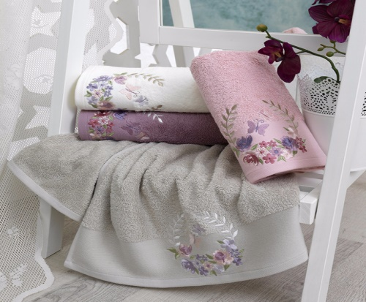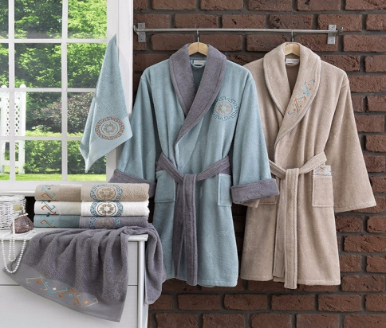

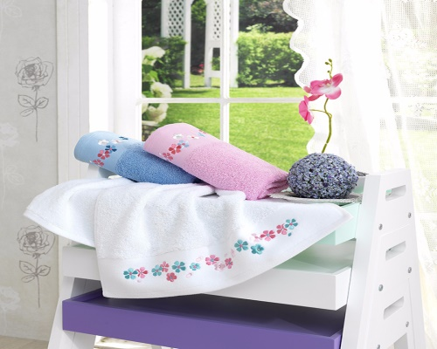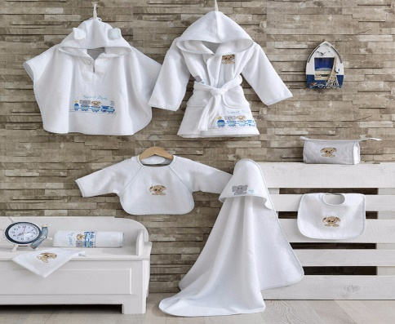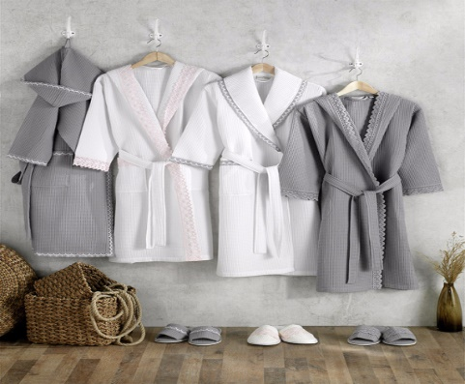

http://www.gelintekstil.com.tr/35/products/

EXPORT DETAILS

EXPORT CAPACITY | %100
HS CODE OF PRODUCTS | 620892000000, 630260000019
DELIVERY TIME | 6-8 week
PACKAGE DETAILS | Single or set, Lot rolls, Assorted packs and rolls, Hull loading
MINIMUM ORDER QUANTITY | 10.000 €

ABOUT US

Gelin Textile was established in 2003 and operates within the Tosunoglu Group. Since 1986, our Textile production start date has been 100% export oriented and has been producing for Europe's leading companies and brands. Besides our own collections, we are able to successfully make collections from our customers. We also have embroidery design / Embroidery machines in our fabric. We can provide all kinds of fabrics in all designs and models in flat / Jacquard / Yarn Dyed fabrics from curly / velvet / Wellsoft / Gelinsoft / Piquee / Knitted Fabrics in all kinds of Towel / Bathrobe / Home Textile group in male / Female.

EQUIPMENT
10 pcs. Dobby Looms
3 Tajima Embroidery Machines
1 Tajima Embroidery Sample Machine
2 Lines for Bathrobe Confection
1 Line forTowel Confection
2 pcs. Tumple cleaning
3 pcs. Iron Machine
Laboratuary

References
MORGENSTERN
TAUBERT
RINGELLA
GUY LAROCHE
VERSACE
BADER
KLINGEL
OTTO WERNER
PLANTIER
CARL ROSS
……….

